**CORE-MODULE 4**

**Name: - Shaik Arshad**

**Trade: - ADIT**

**Register No.:- ADIT22AP02767**

**Q1) Web Application using Django framework to create a home page**

Aim: -Web Application Home page.

Requirement: - virtual environment,

Django

Pip

VS Code

Algorithm: -

Step 1: - First create a folder.

Step 2: - open the folder and type cmd.

Step 3: - After the open command install the virtual environment using the command

“ Virtualenv env ”.

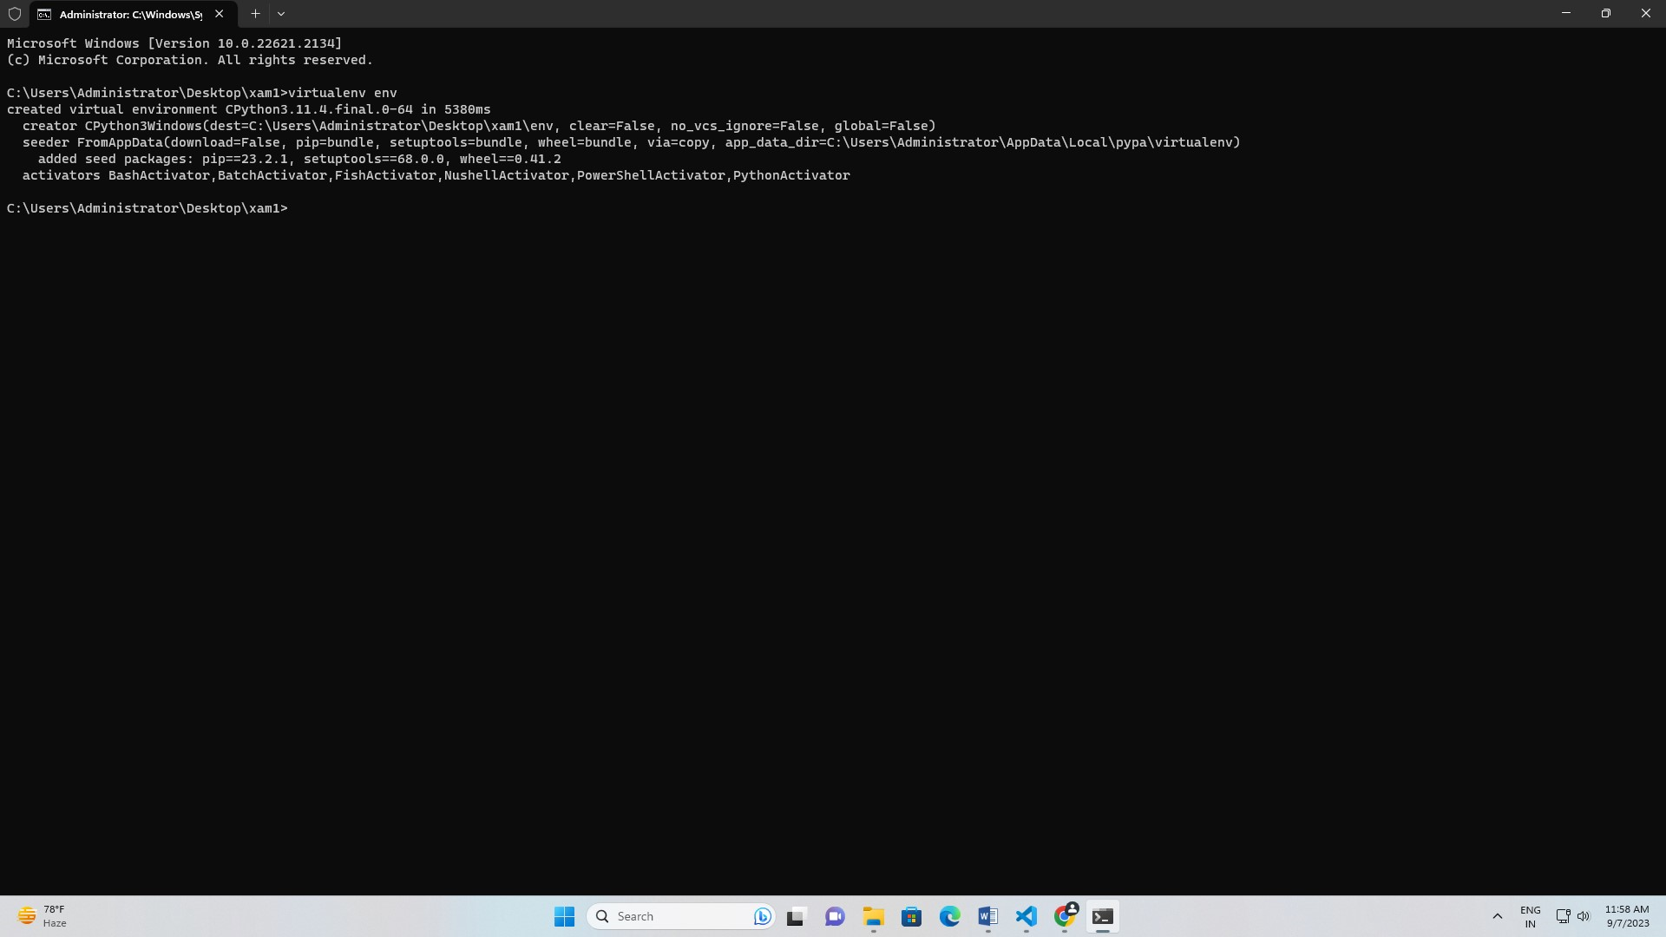

Step 4: - activate the virtualenv

“cd env”.

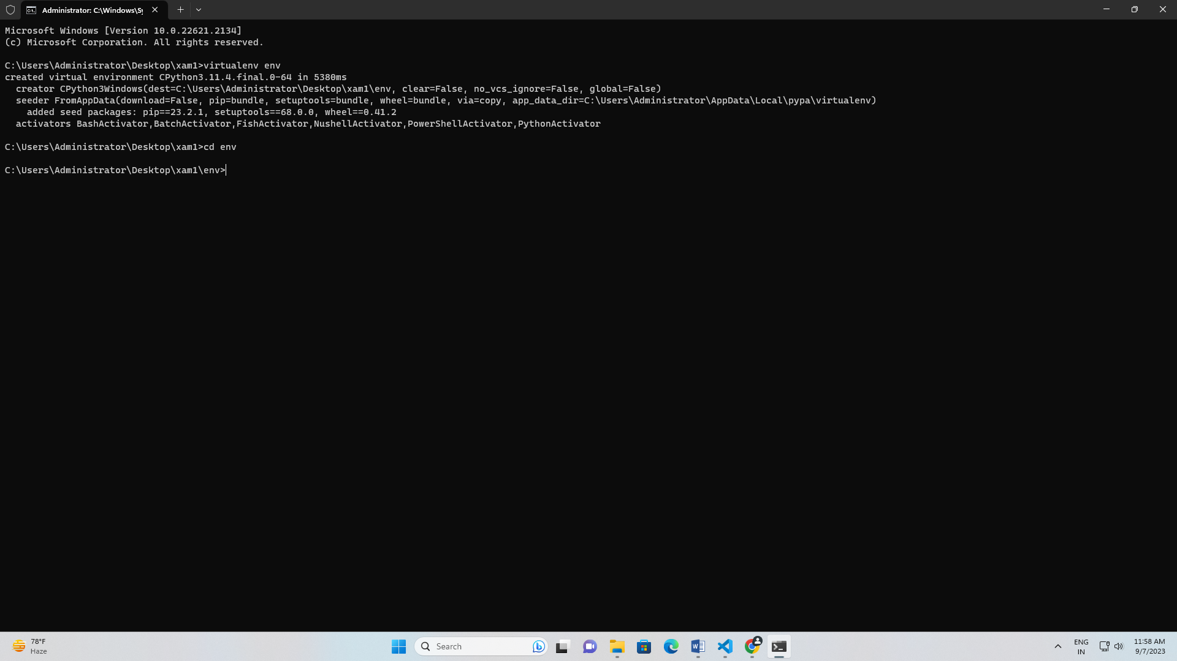

“cd scripts”

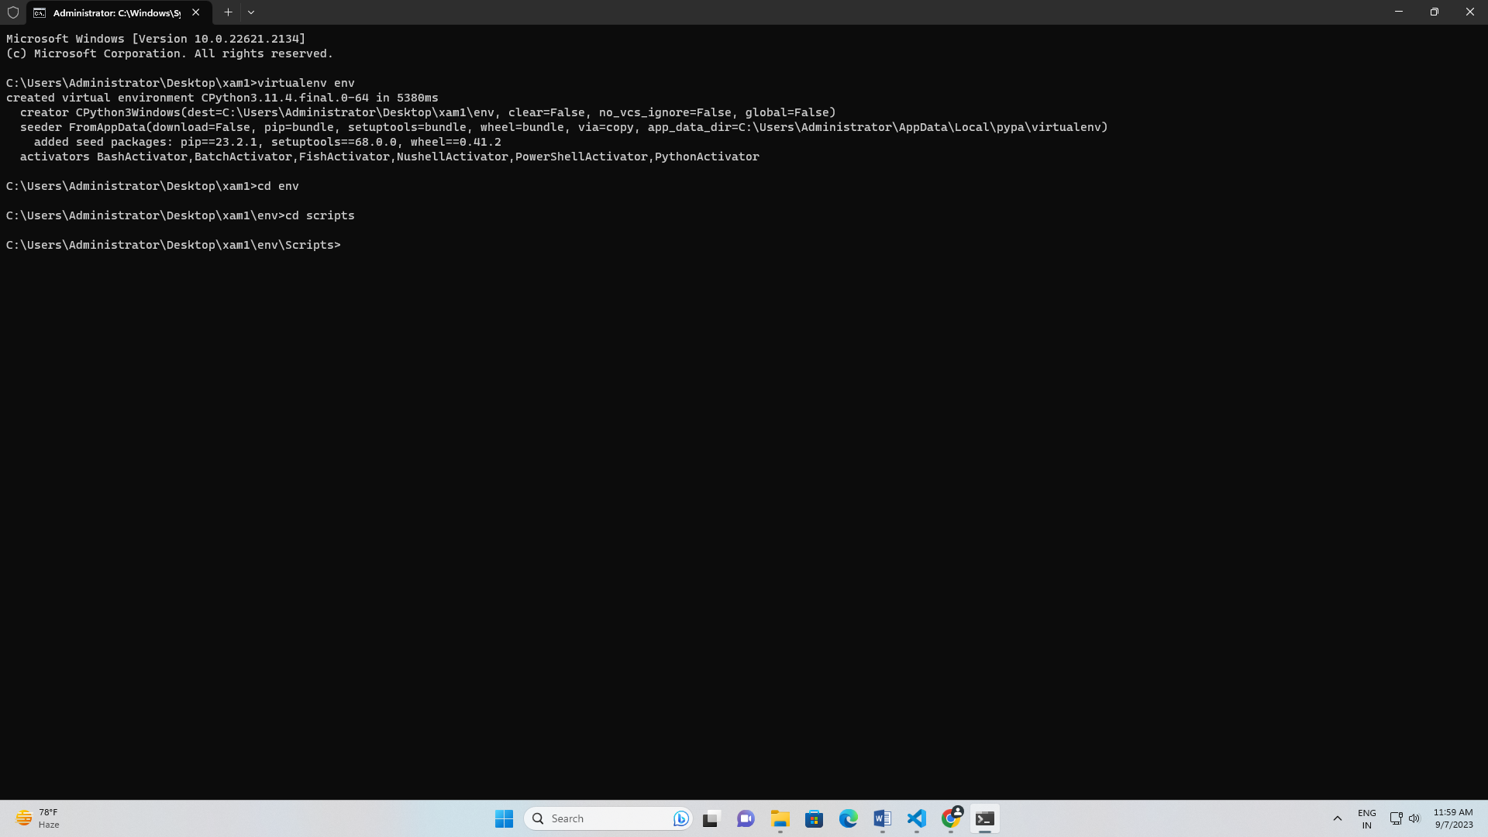

“activate”.

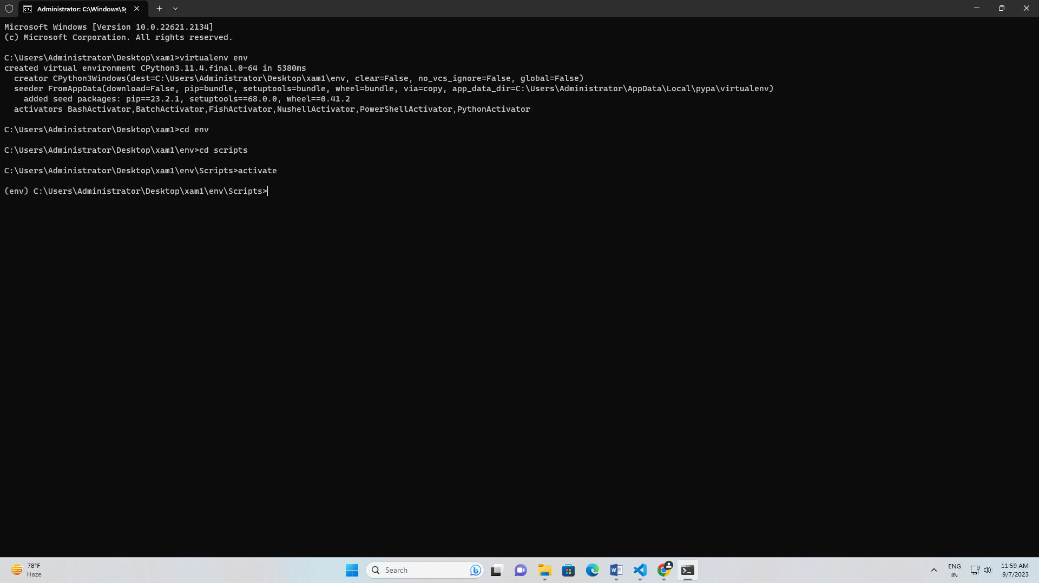

Step 5: - Then come out from the virtual environment using command

“cd..” until u come out form the virtual environment.

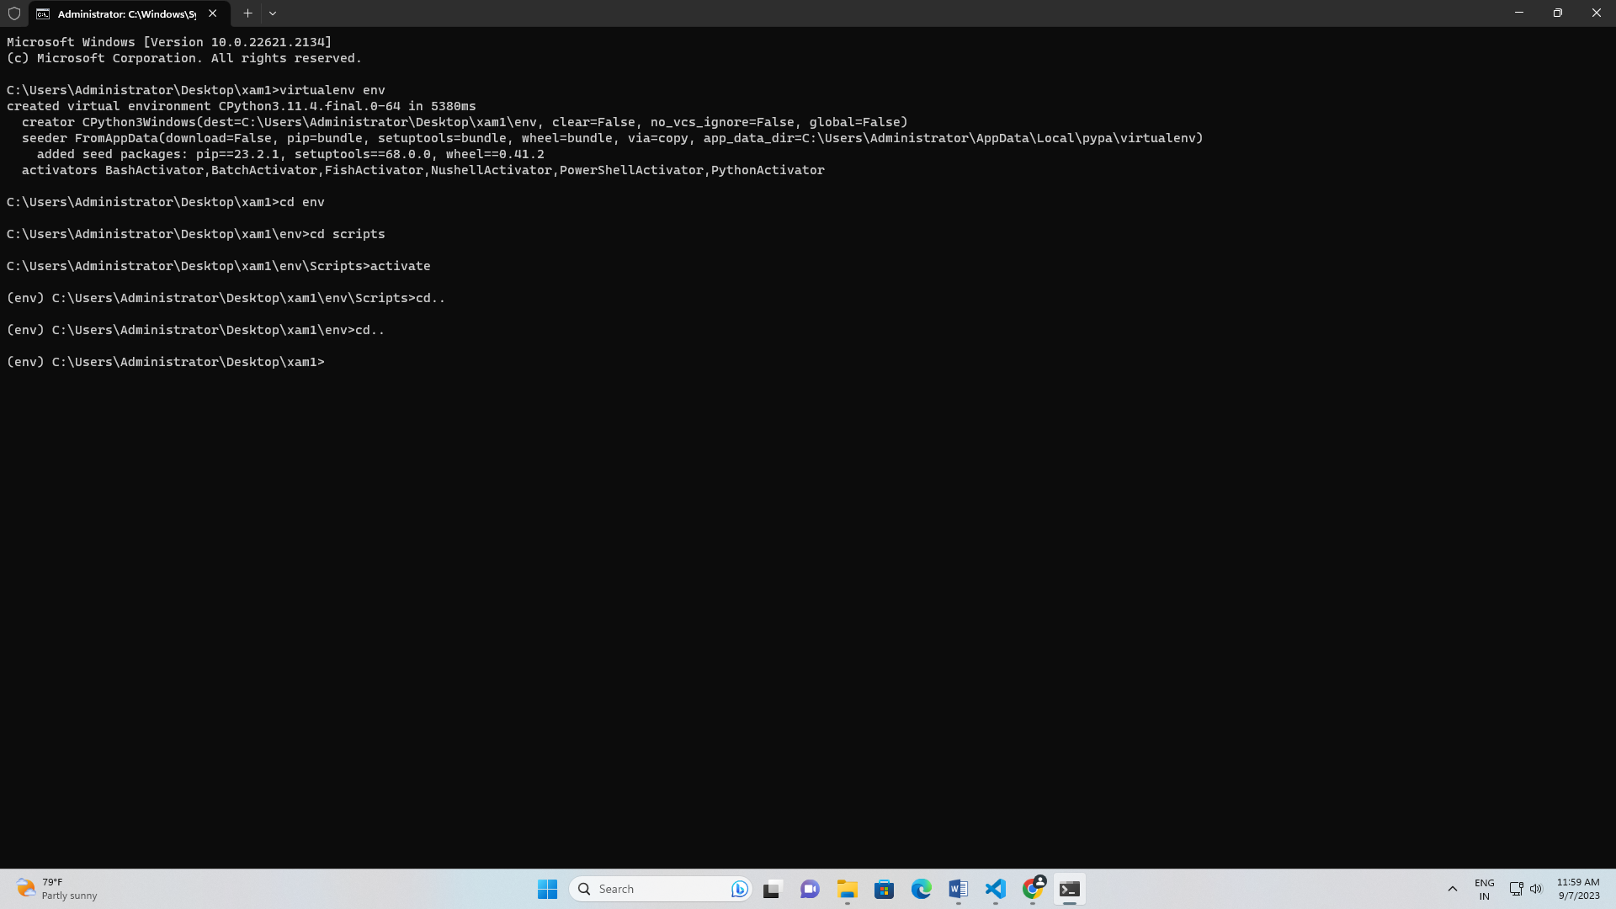

Step 6: - install Django throw command “pip install Django”.

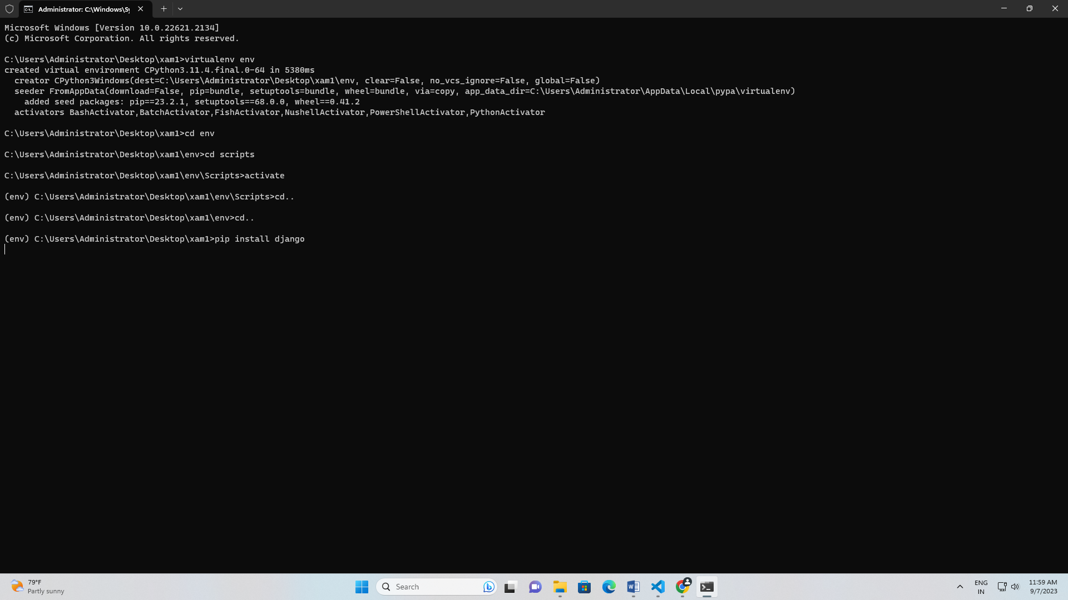

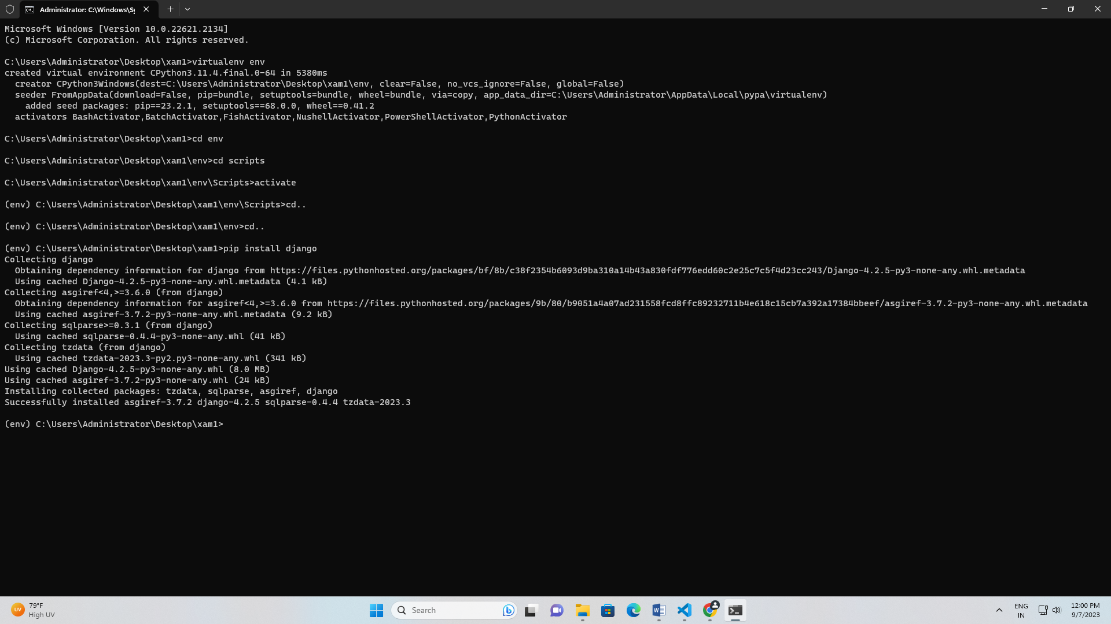

Step 7: - create the project with name of pro using command “Django-admin startproject pro”.

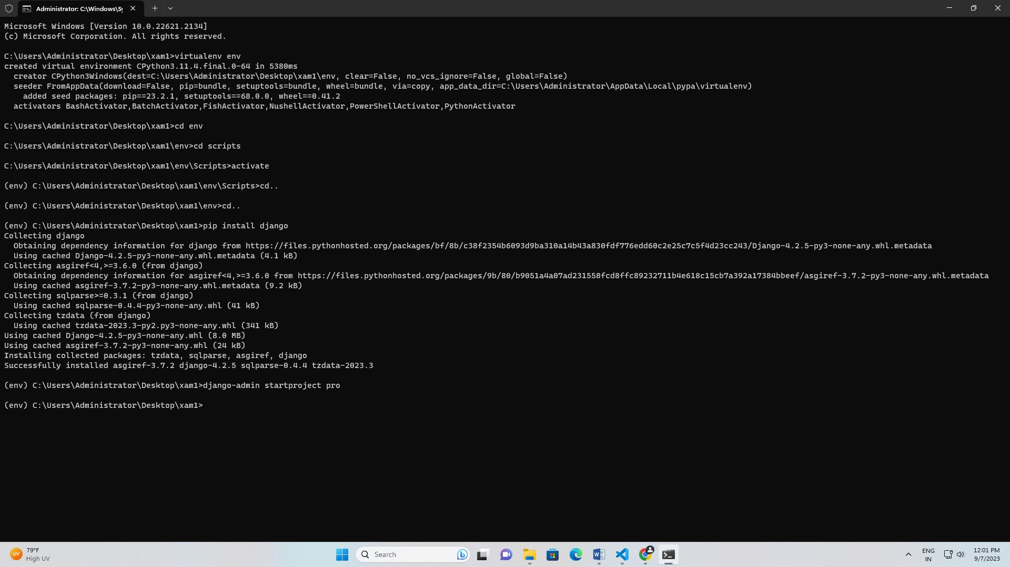

Step 8: - then check the project is working or not. “Py manage.py runserver”.

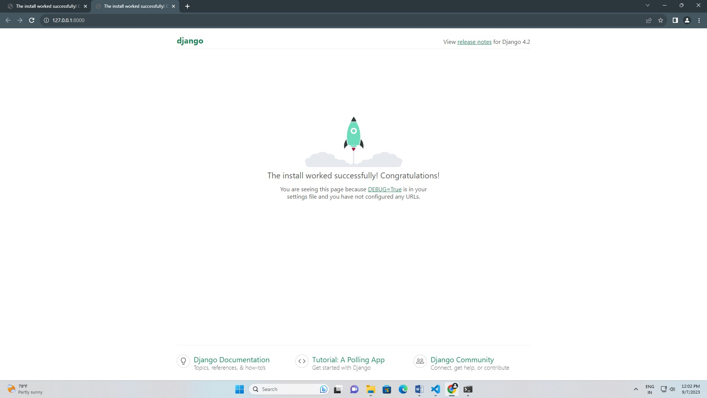

Step 9: - inside project create one app (app) using command “Django-admin startapp app”.

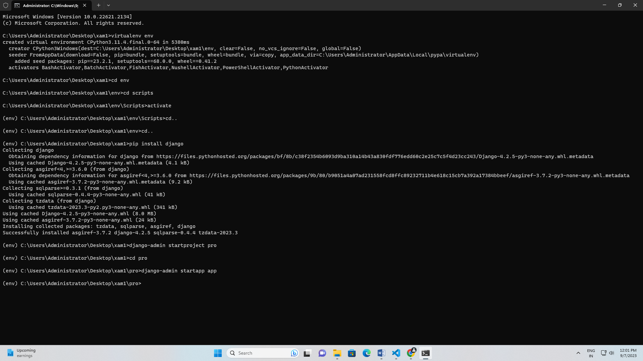

Step 10: - come out from the app and enter the vs code. With using command “code .”

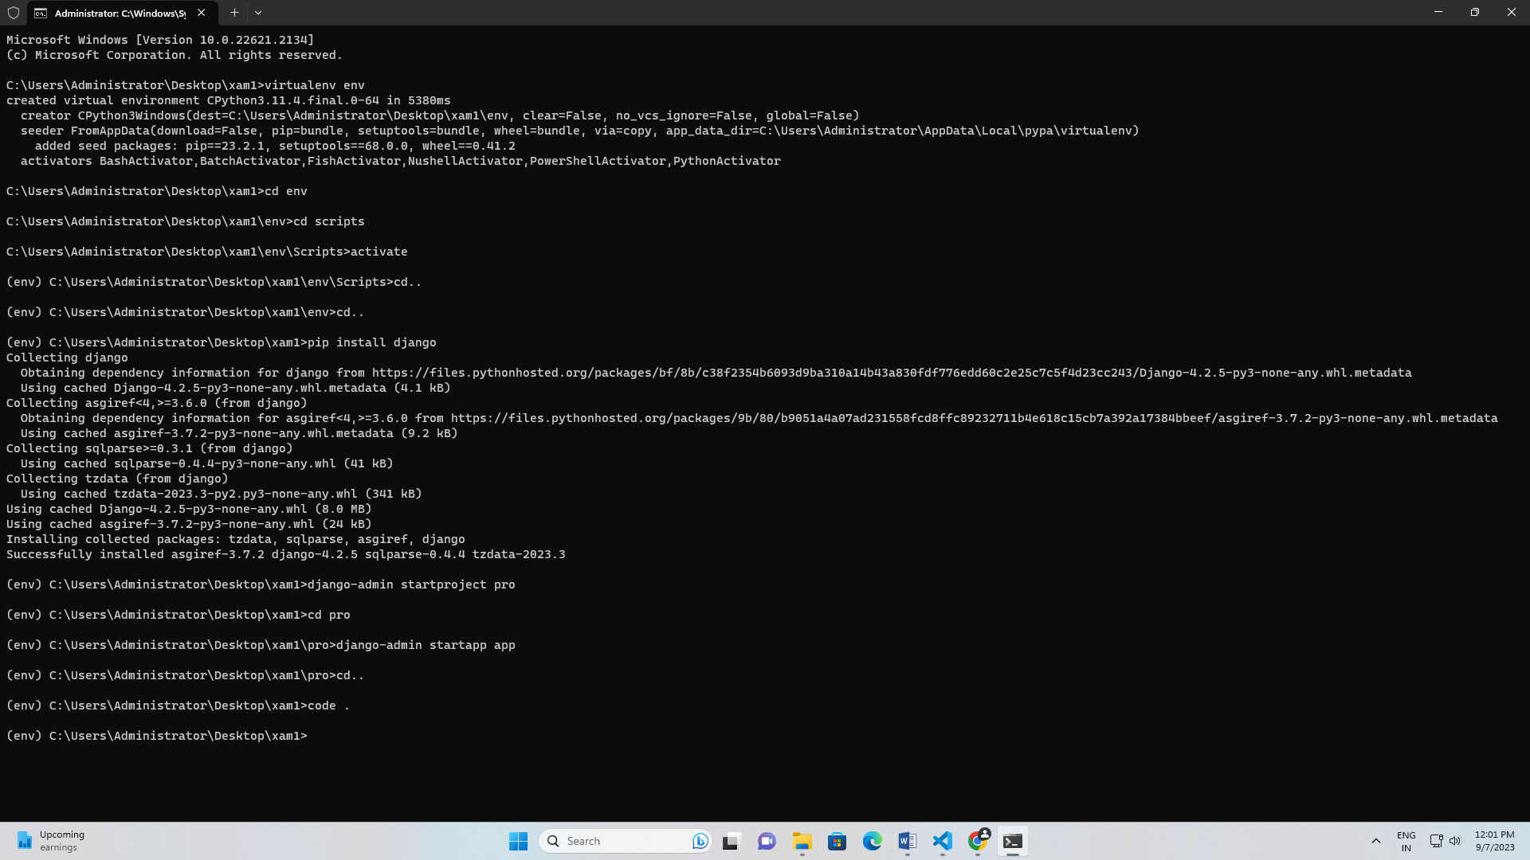

Step 11: - After enter the vs code check the settings.py and add the application.

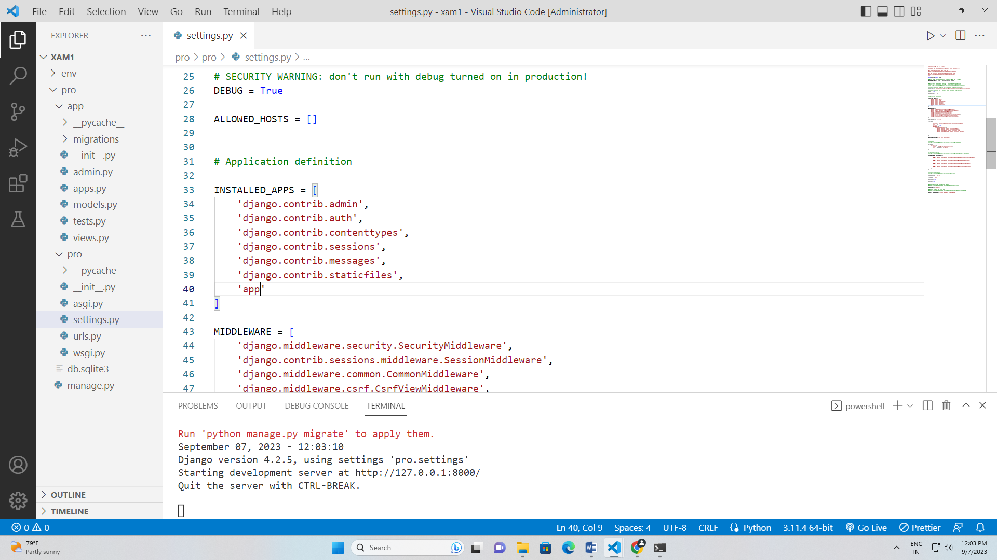

Step 12: - in application create the templates folder for html files.

In templates folder create the index.html file.

Step 13: - Enter the views.py file and type the code and bind the code with html code.

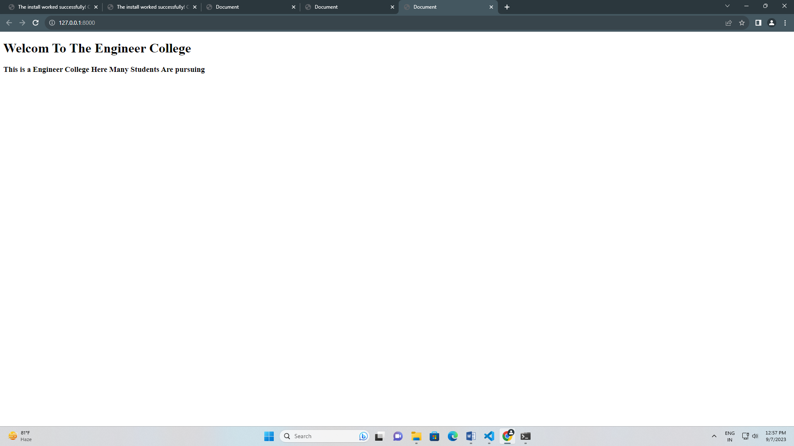

**Q.2) Upload an Image file in Django.**

Aim: - Upload an image file in Django.

Requirement: - virtual environment,

Django

Pip

VS Code

Algorithm: -

Step 1: - First create a folder.

Step 2: - open the folder and type cmd.

Step 3: - After the open command install the virtual environment using the command

“ virtualenv env ”.

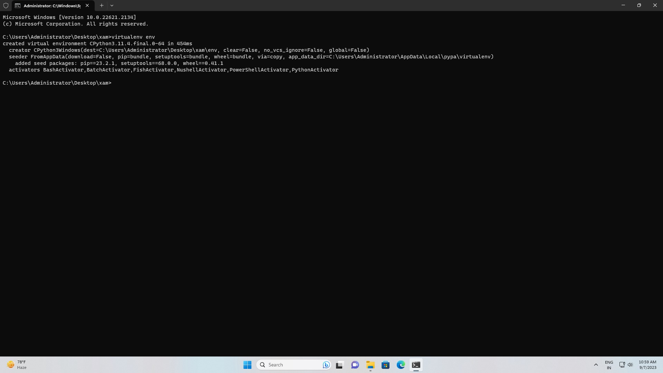

Step 4: - activate the virtualenv

“cd env”.

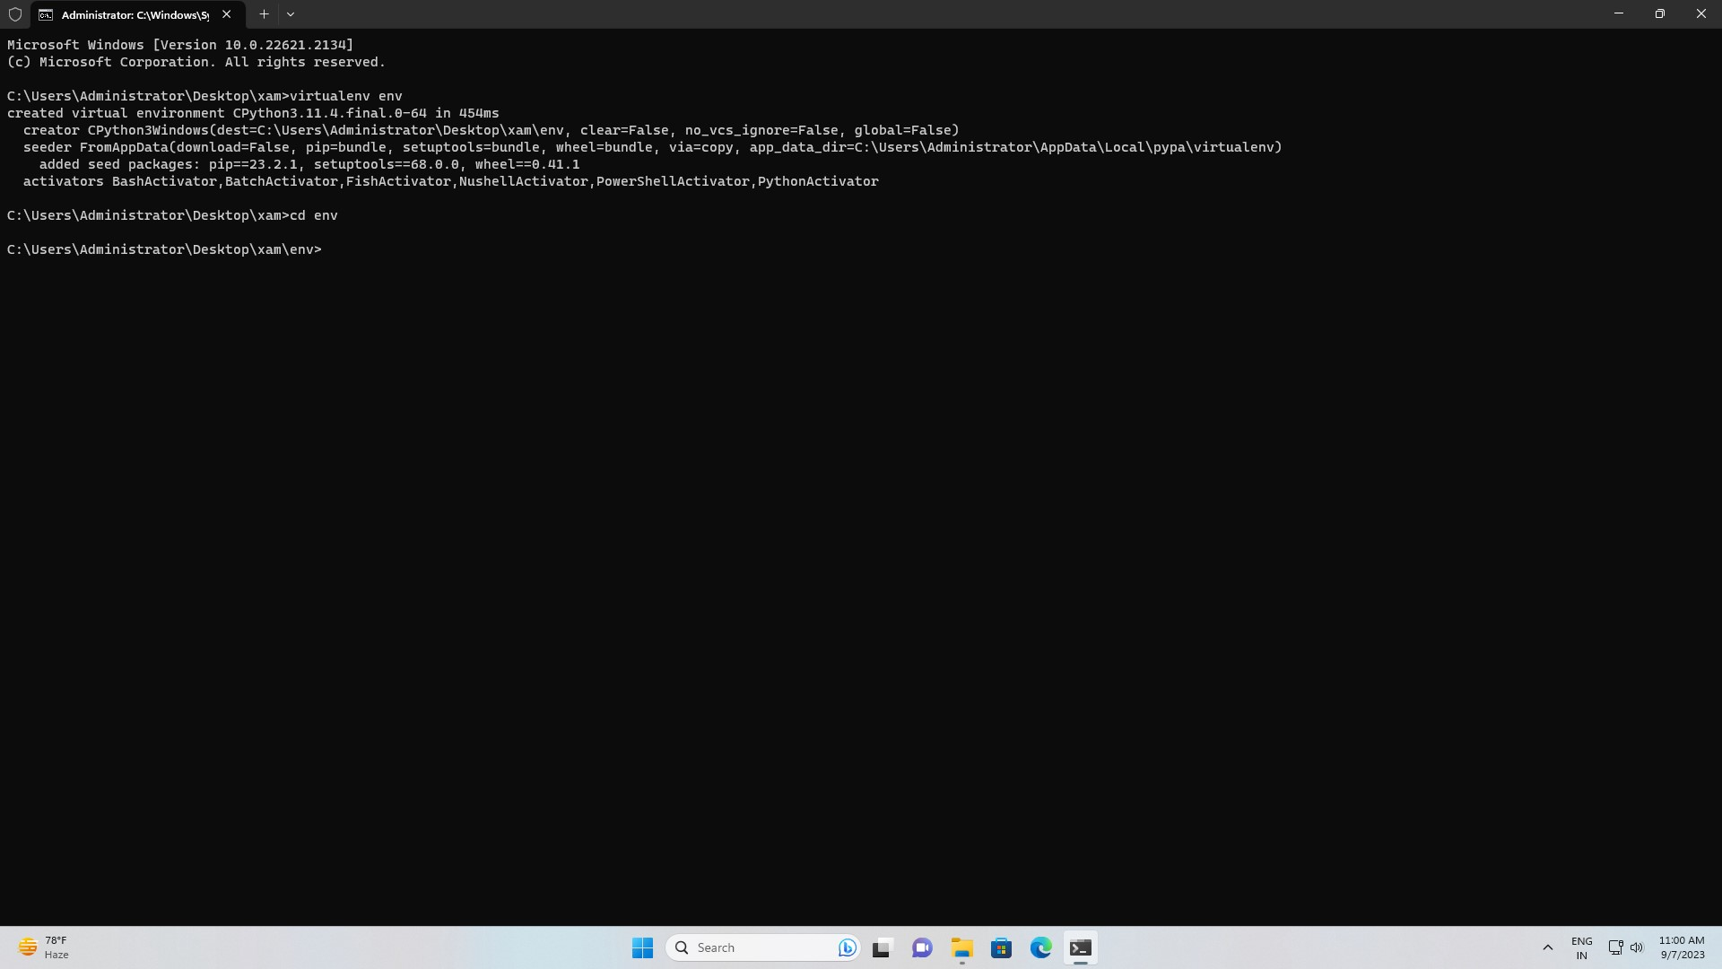

“cd scripts”

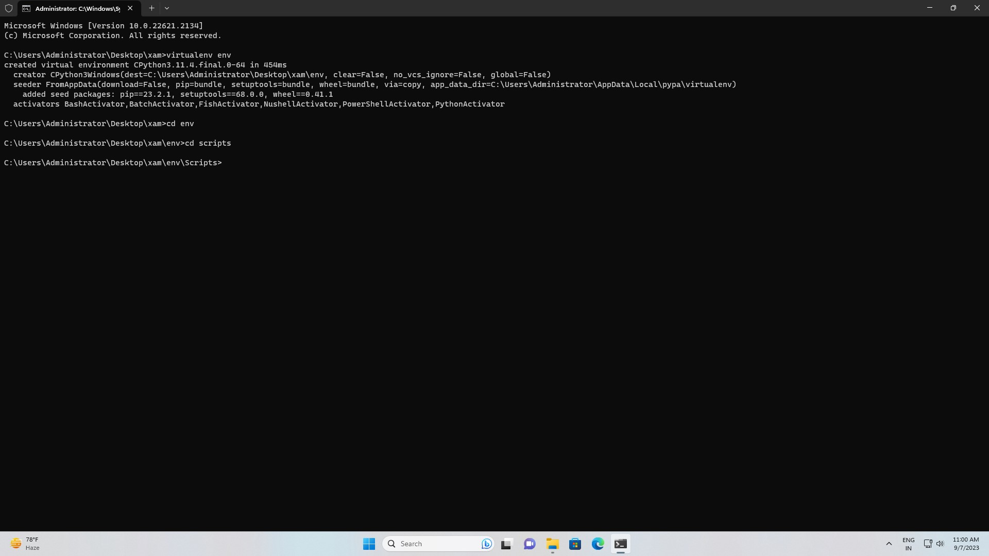

“activate”.

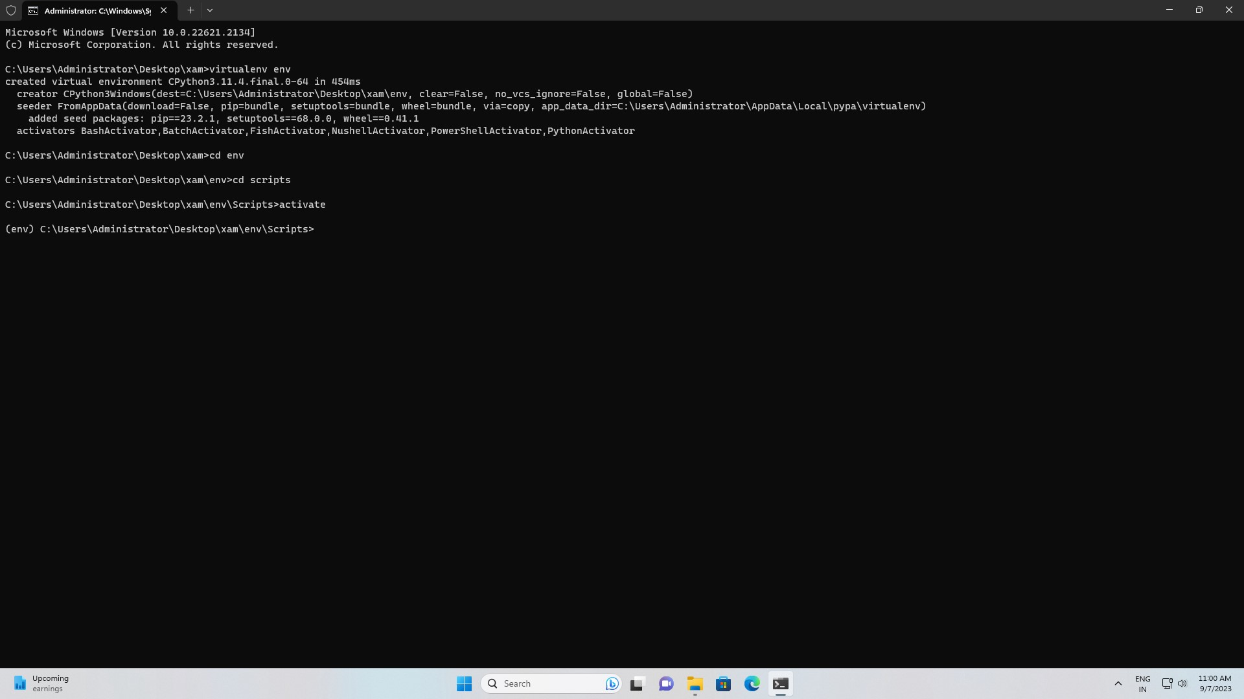

Step 5: - Then come out from the virtual environment using command

“cd..” until u come out form the virtual environment.

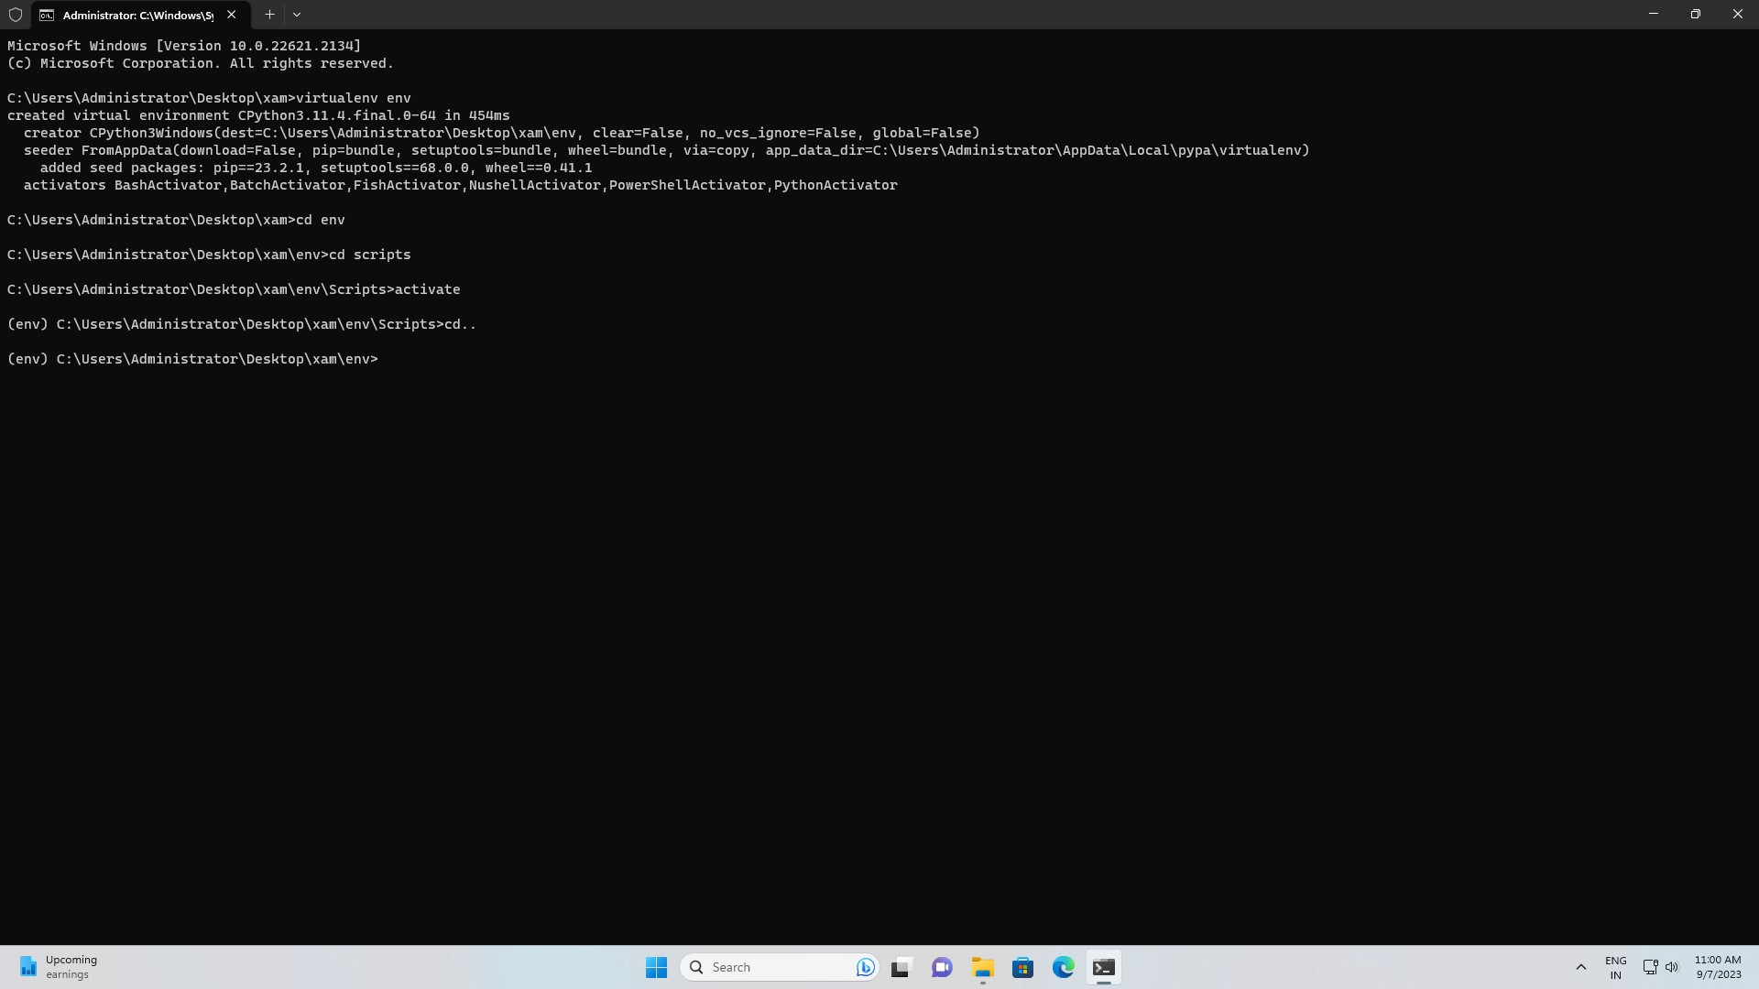

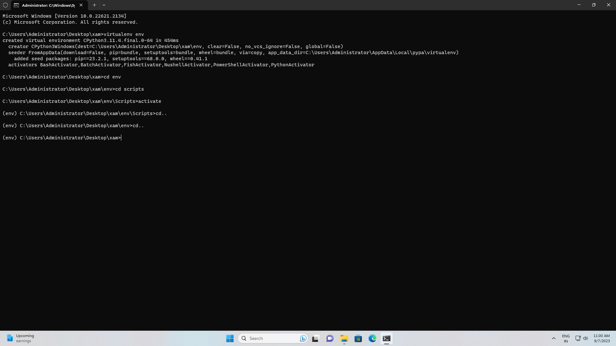

Step 6: - install Django throw command “pip install Django”.

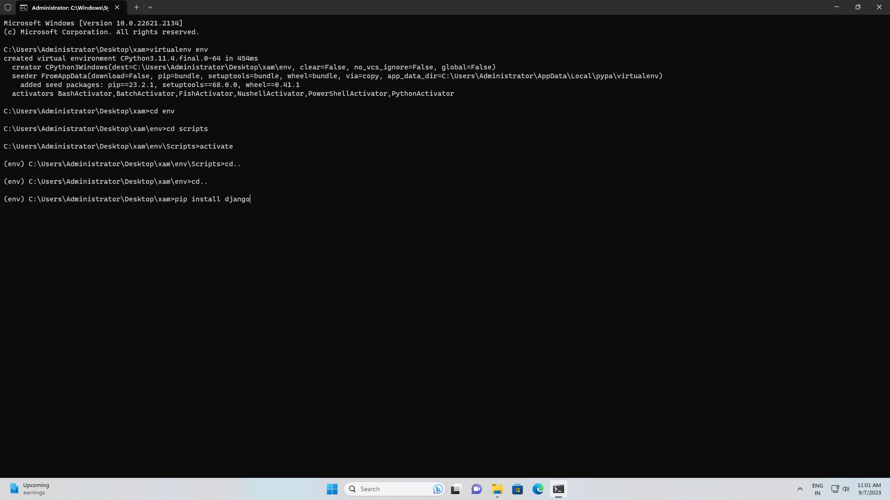

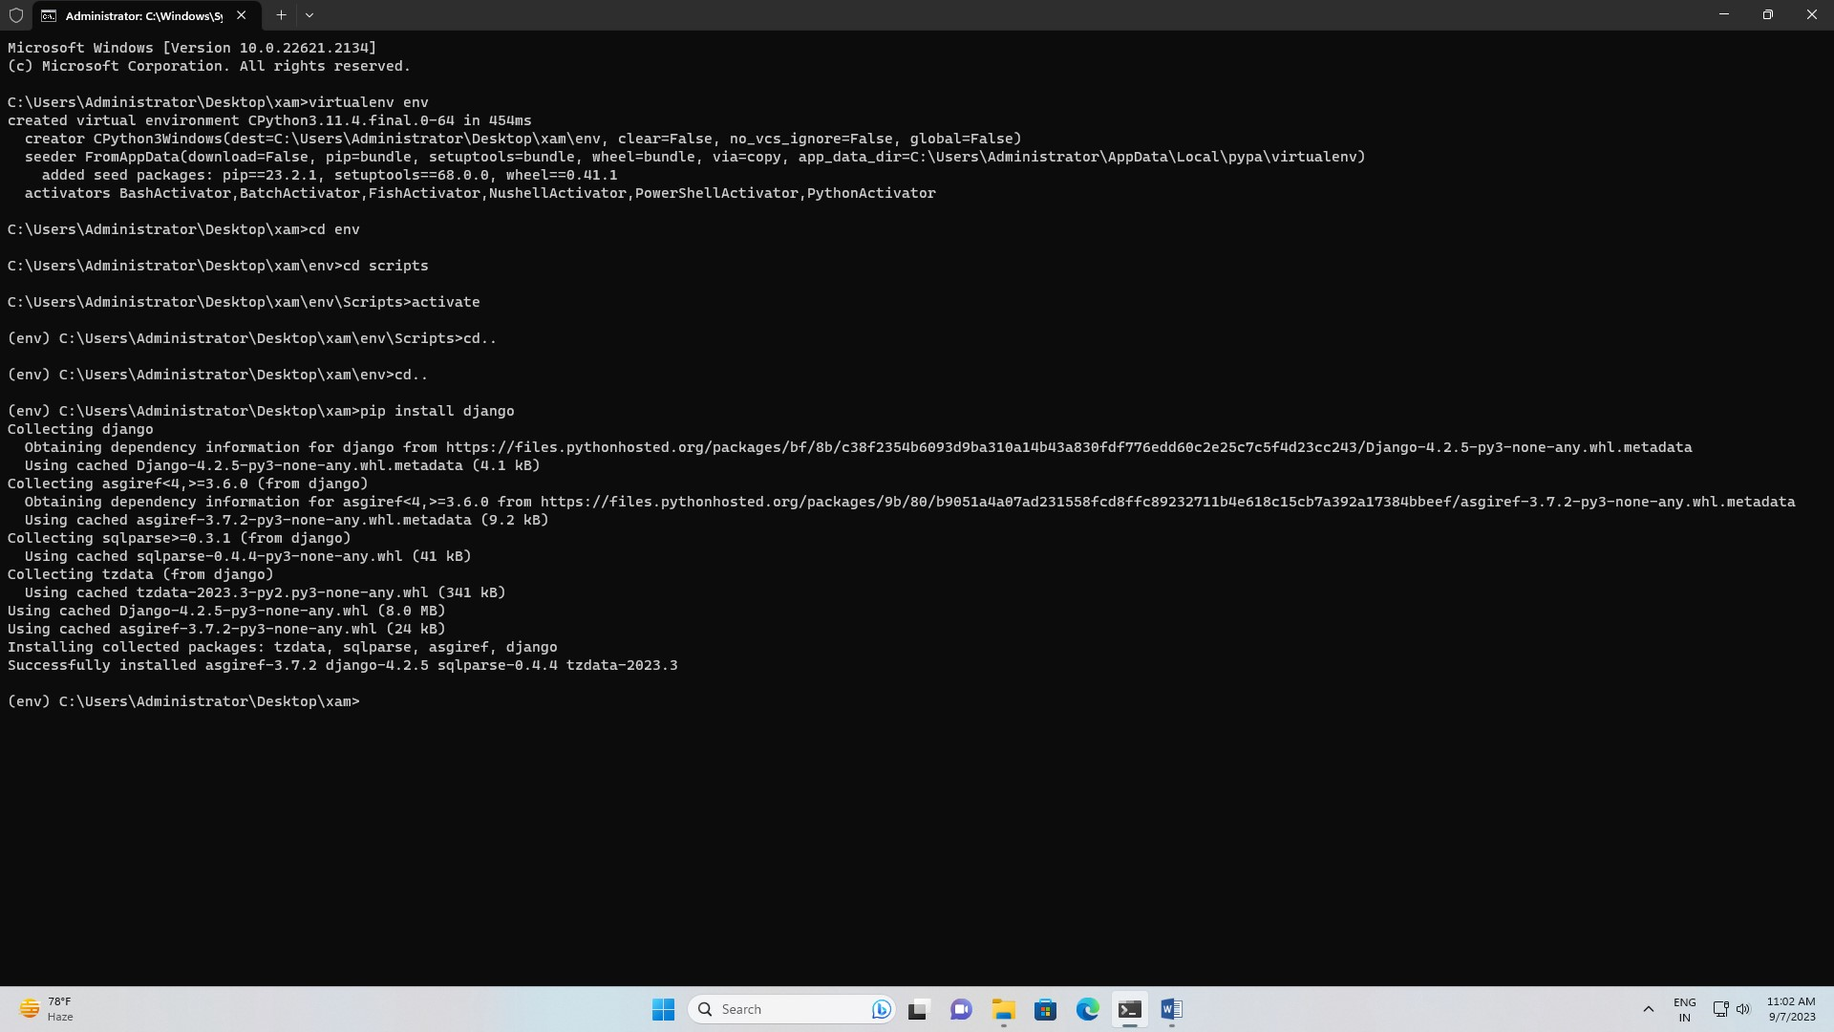

Step 7: - create the project with name of pro using command “Django-admin startproject pro”.

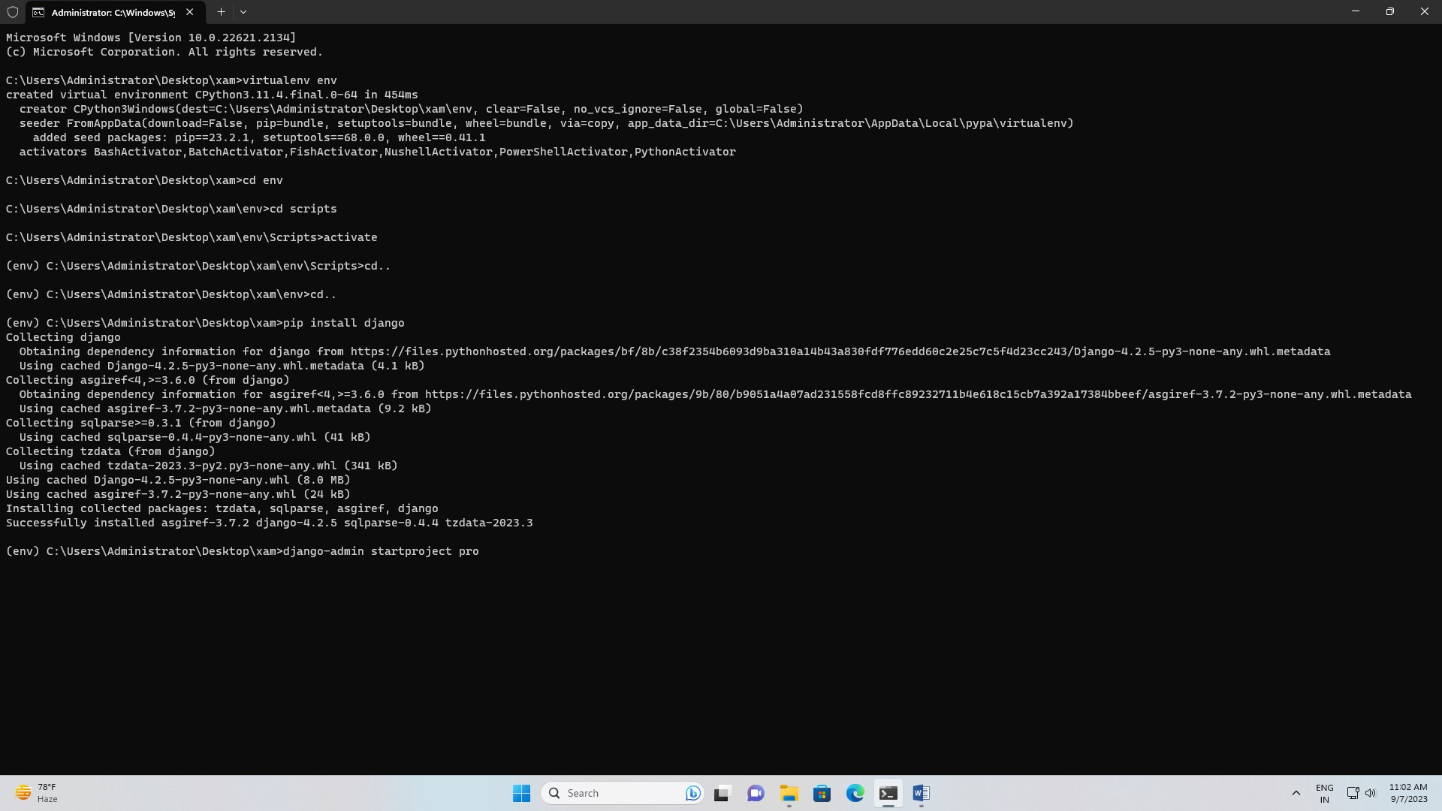

Step 8: - then check the project is working or not. “py manage.py runserver”.

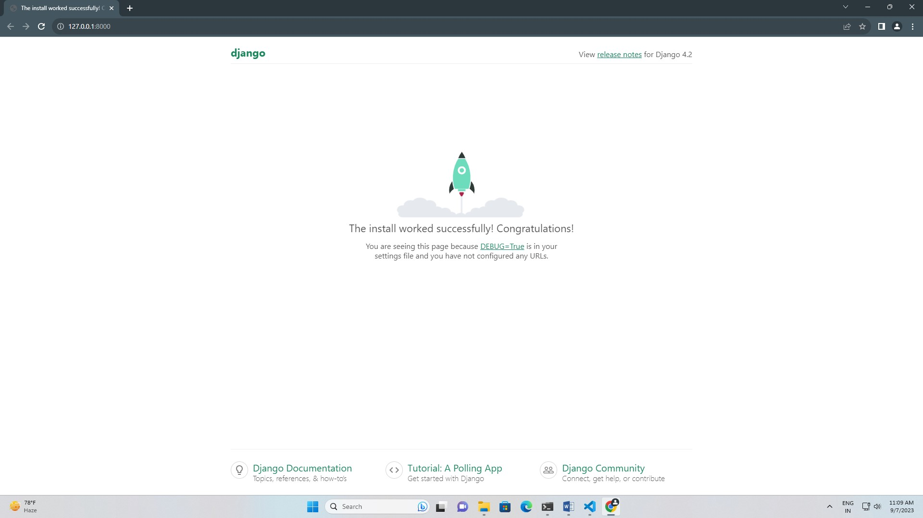

Step 9: - inside project create one app (app) using command “Django-admin startapp app”.

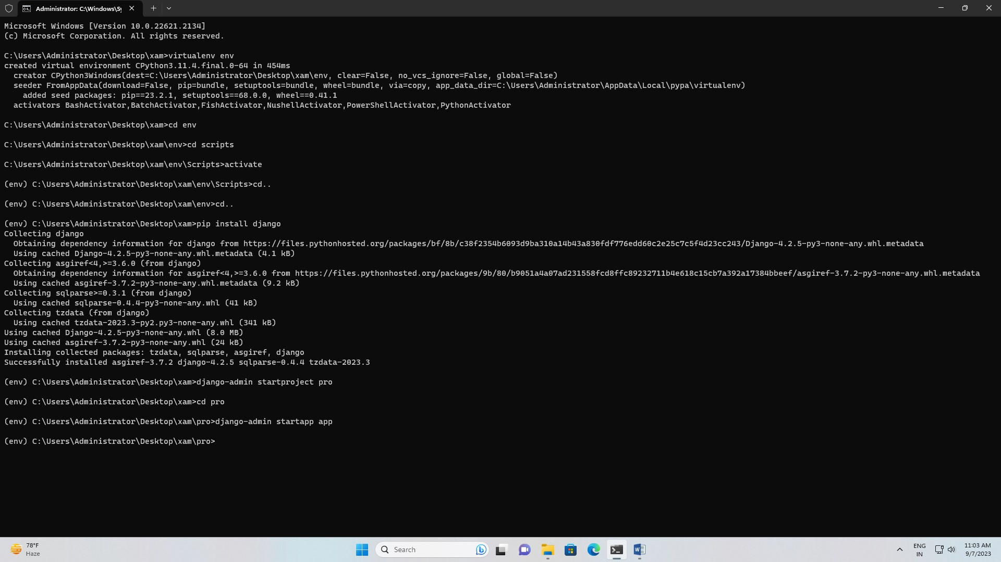

Step 10: - come out from the app and enter the vs code. With using command “code .”

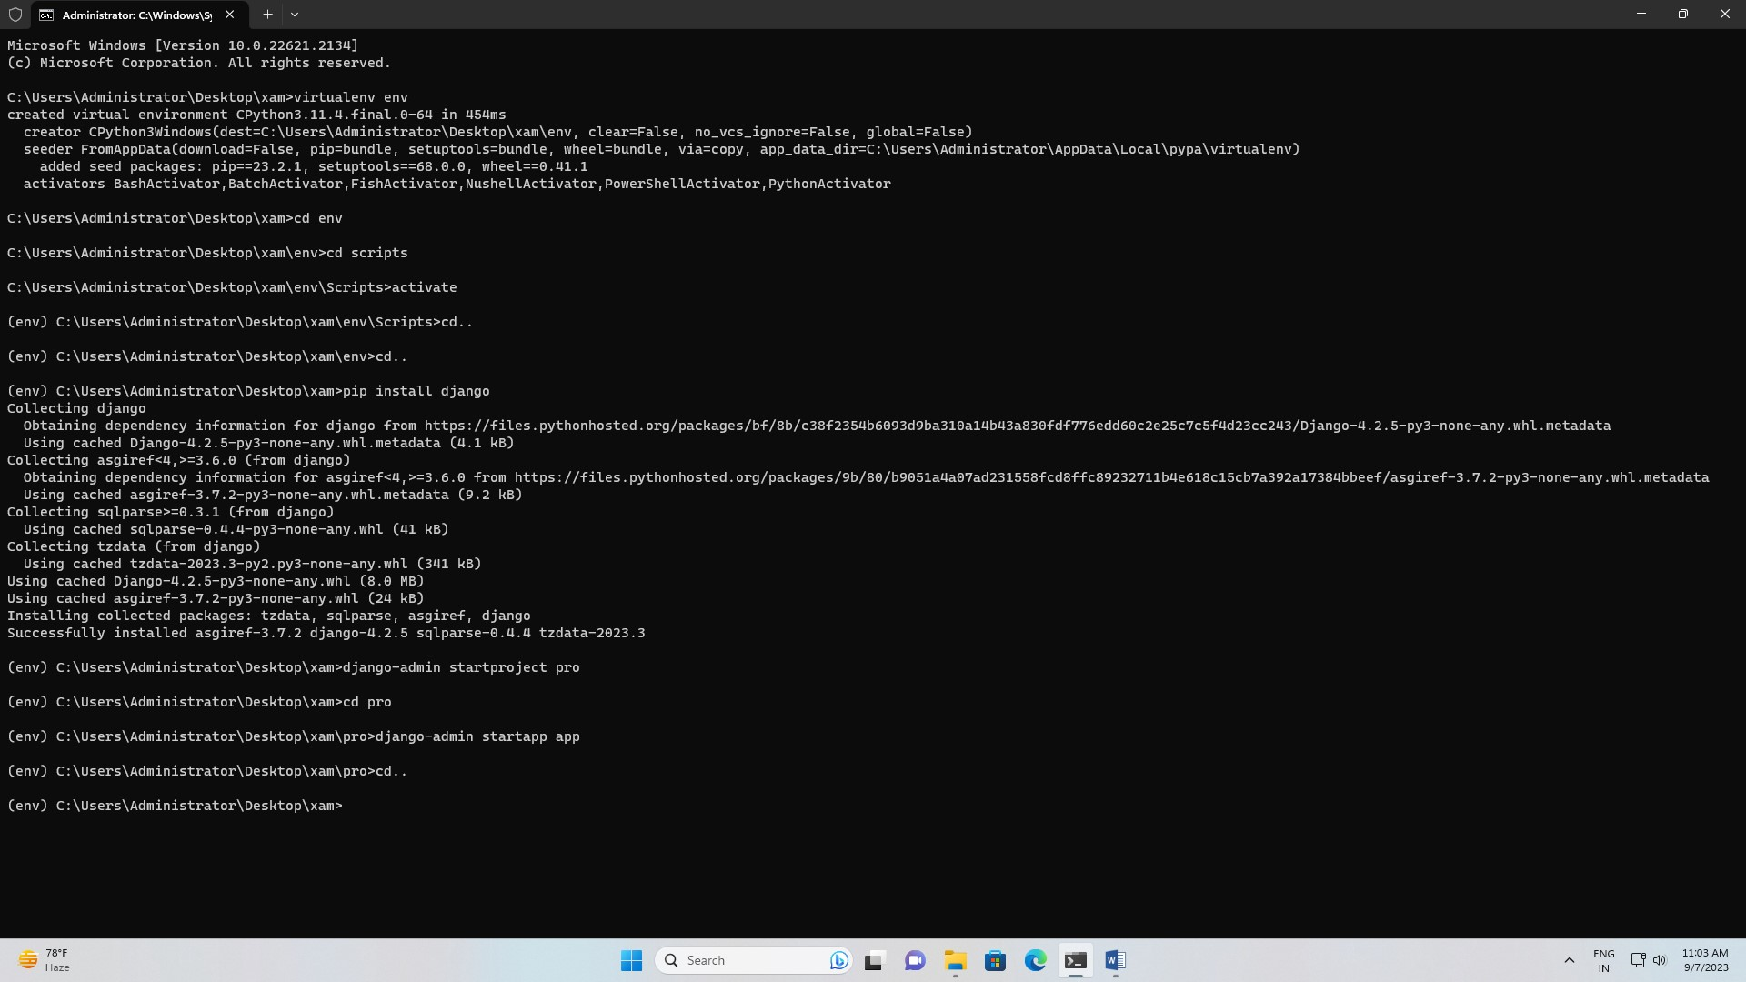

Step 11: - After enter the vs code check the settings.py and add the application.

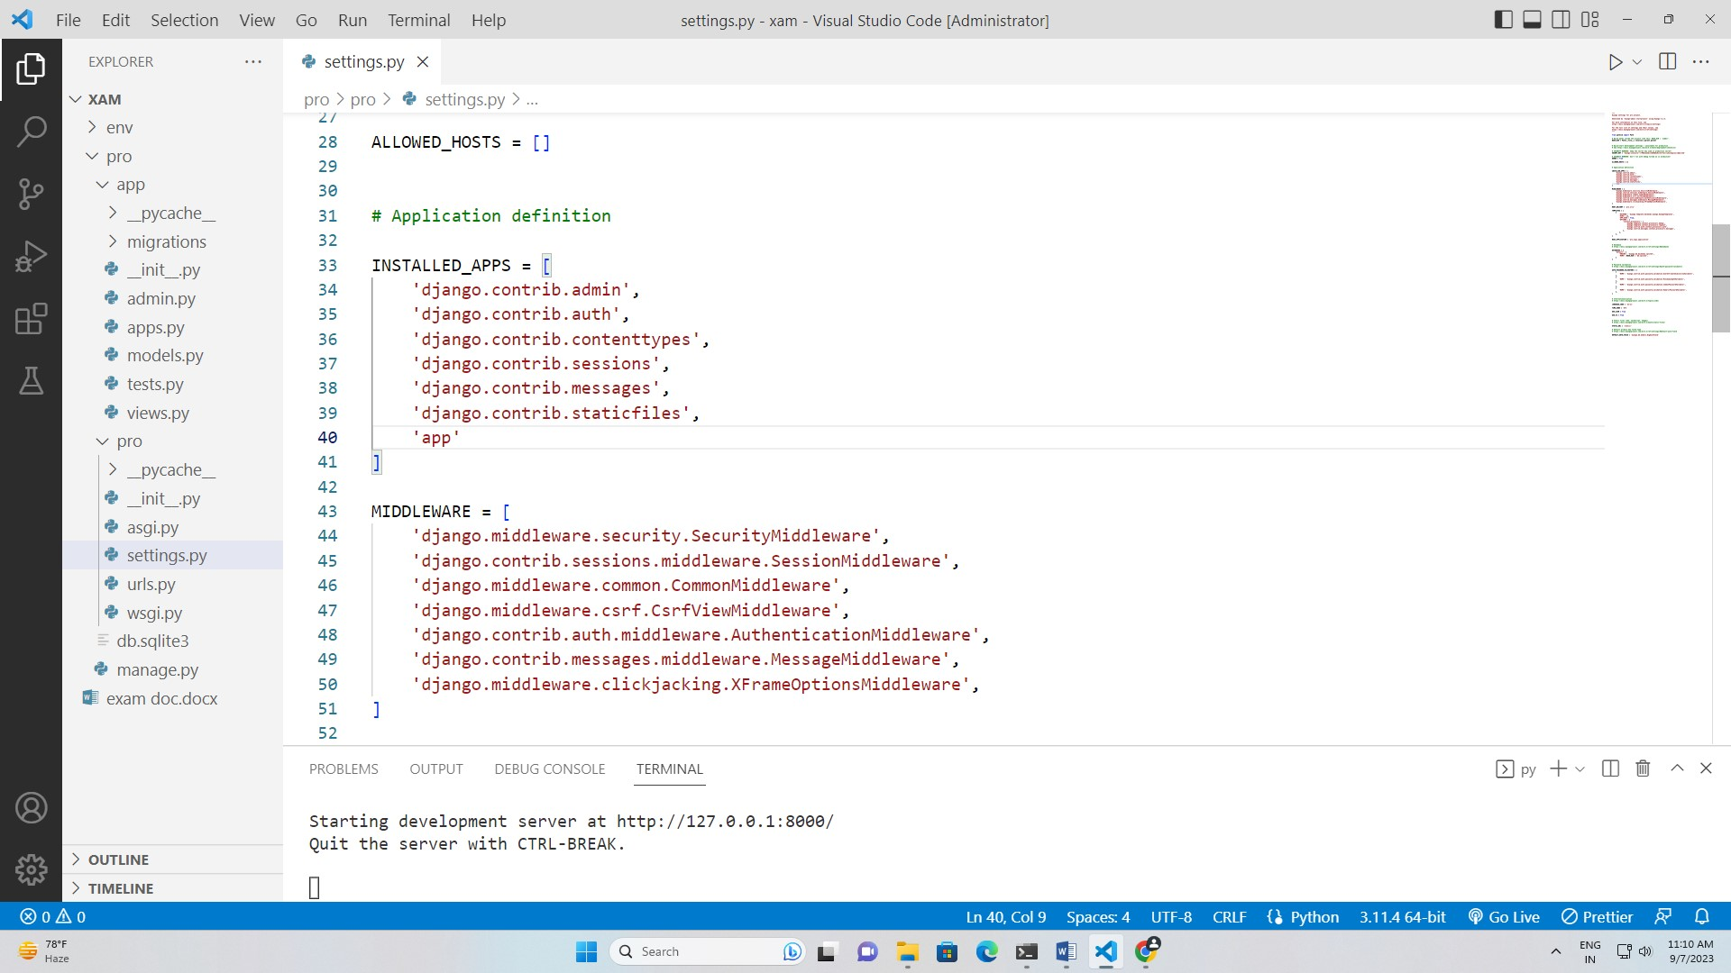

Step 12: - in application create the templates folder for html files and static folder for upload the file.

In templates folder create the index.html file.

Step 13: - create the forms and functions.py files for program.

Step 14: - set the location of file in urls.py.

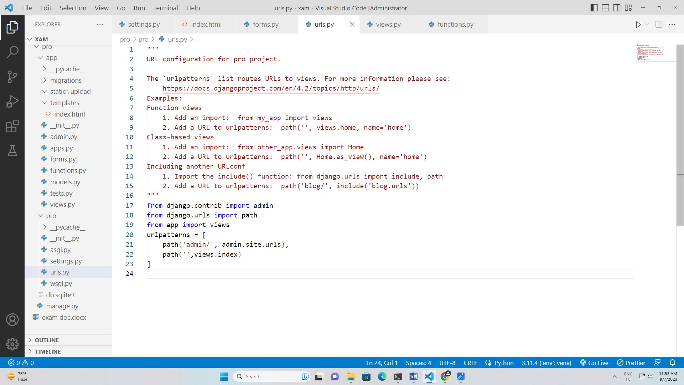

Step 15: - enter in index.html file and type the code same like in other files type the code.

Step 16: - execute the code on browser with “py manage.py runserver”.

Step 17: - The finally your code would execute on browser.

